Singleton class

That class of which we can create only one object

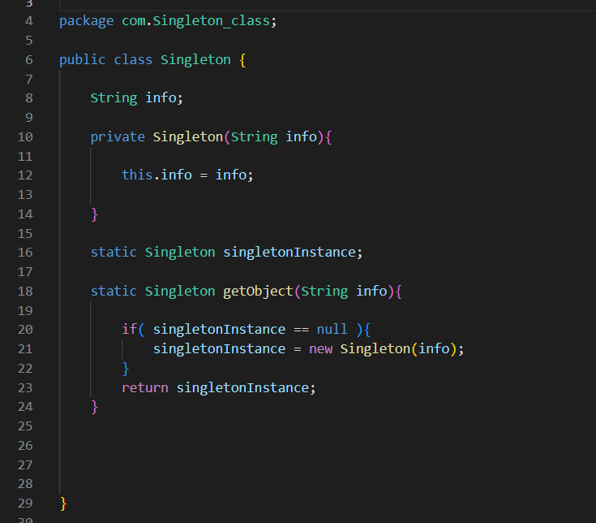

Here constructor is private so no one can create as many object as they want

Also to make one object a method is provided instead, here called getObject( )

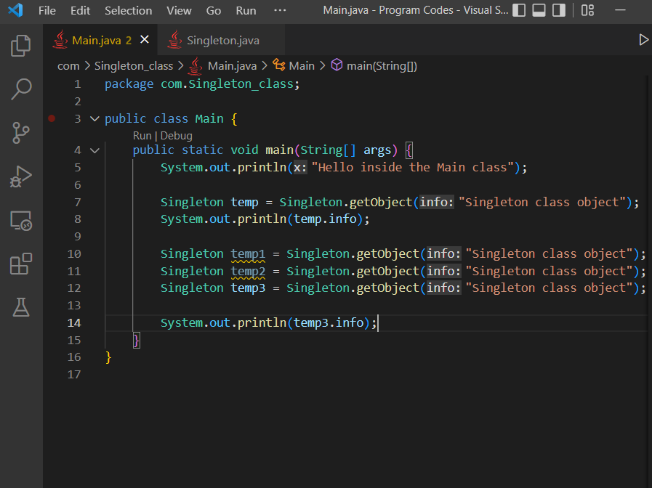

Suru maa object banaeko hudainaa, so to call getObject ( )method we use class name itself, so getObject ( )method needs to be static

Also the variables used inside the getObject( ) method also needs to be static as well

Also the static variable of singletonInstance means that only one variable is created at a special place in heap memory during the compiling of the class file, and if this is null than one object is created and associated to it and is returned, if it is not null than same object is returned

So here all the temp1, temp2, temp3 points to the same object

**Conclusion**

If one object is not created than it will create it and return it

If one object is already created than it will return that